LAB ASSIGNMENT-20
TASK-1:
Prompt:
Generate a Python script that connects to a database or API.
Code and Output:
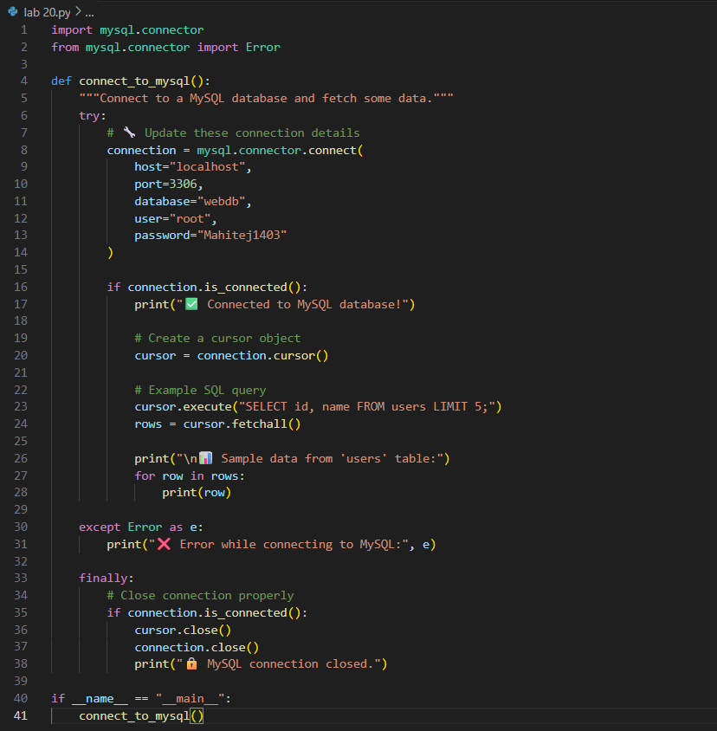
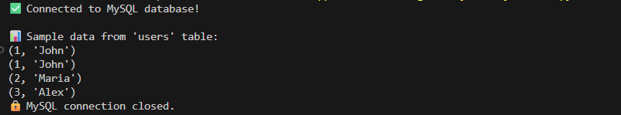

Detection of Hardcoded Credentials:
Yes — the code does contain hardcoded credentials:
- user="your_username"
- password="your_password"
Even though they’re placeholders, this pattern is insecure if used in production or shared code, because it exposes sensitive information directly in the script.

Prompt:
Modify the code to securely load credentials from environment variables.

Code and Output:
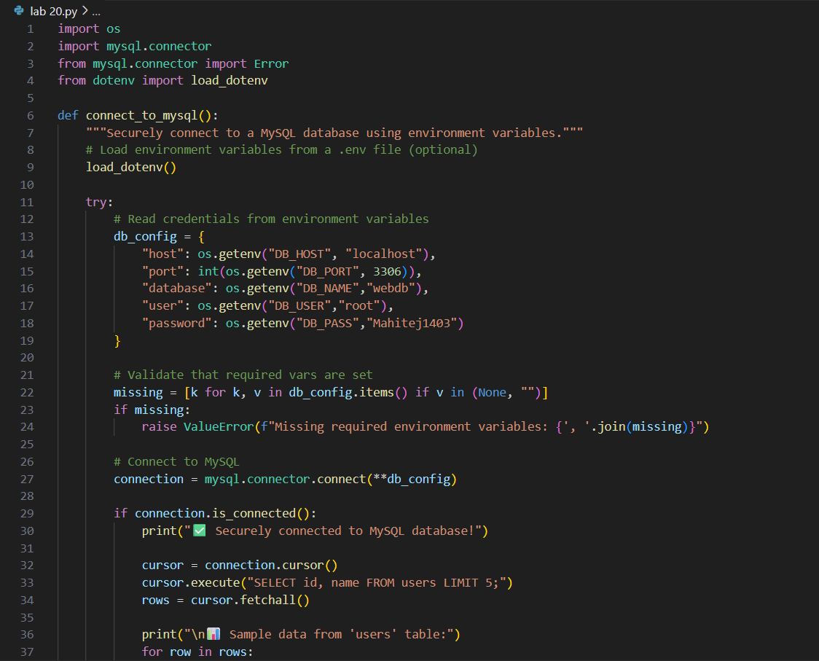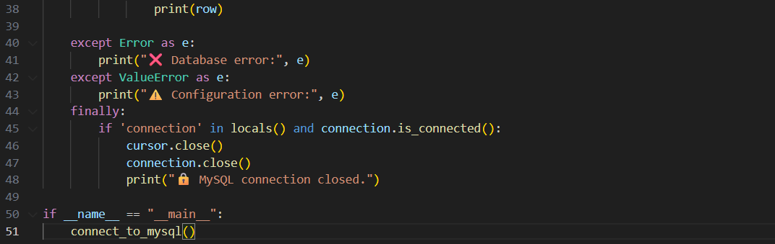

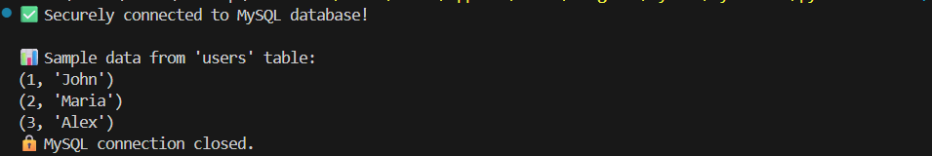

TASK-2:
Prompt:
Generate a simple login system in Python (with SQLite or MySQL).

Code and Output:
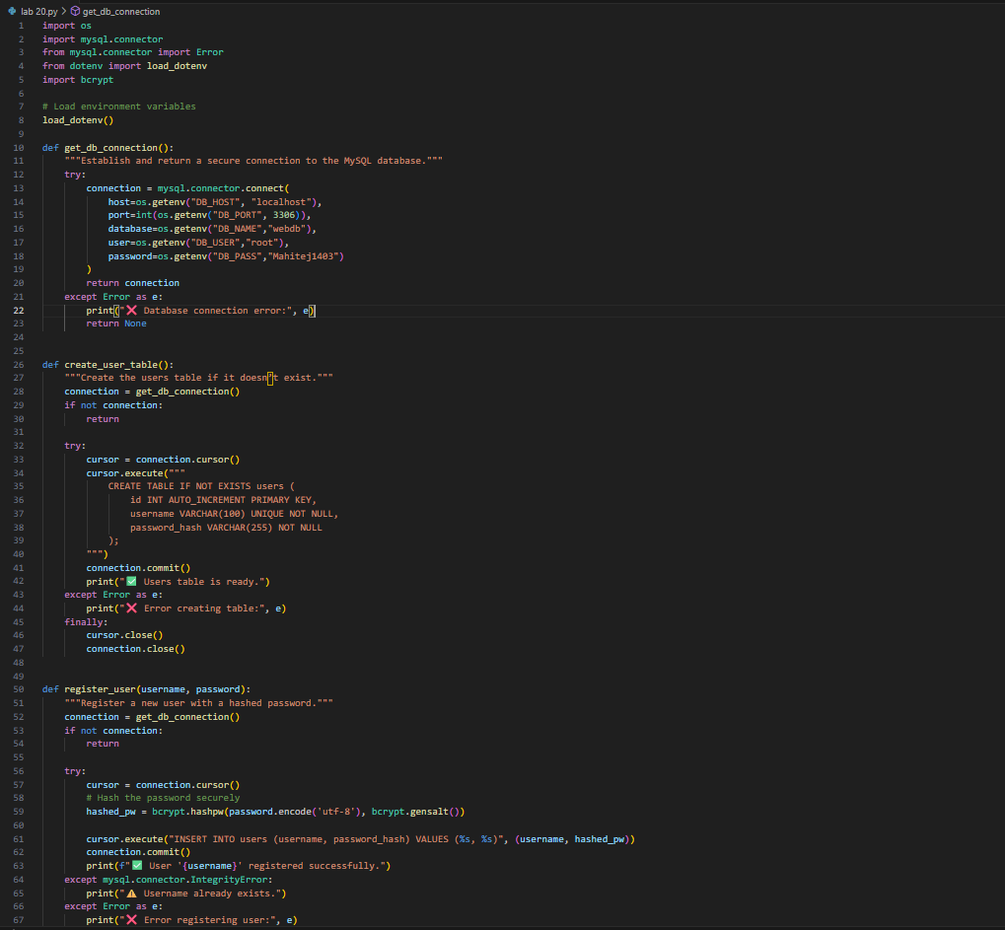
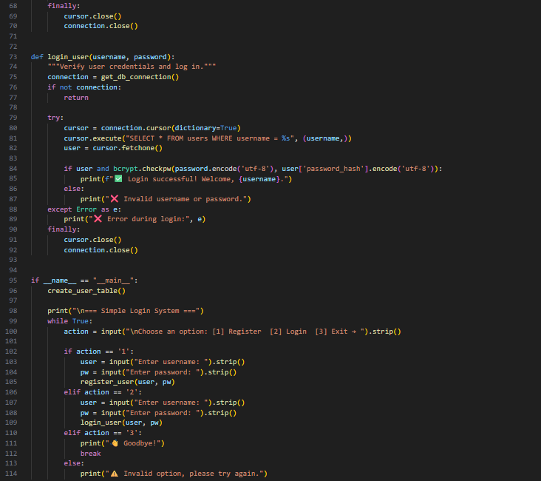

Prompt:
Rewrite the code using parameterized queries to prevent injection.
Code and Output:
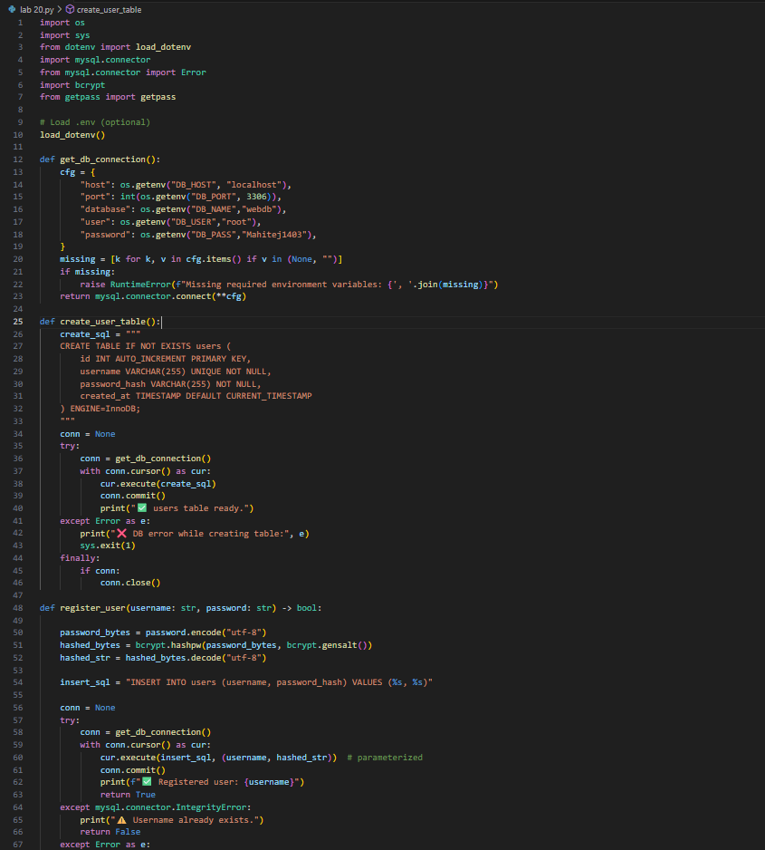
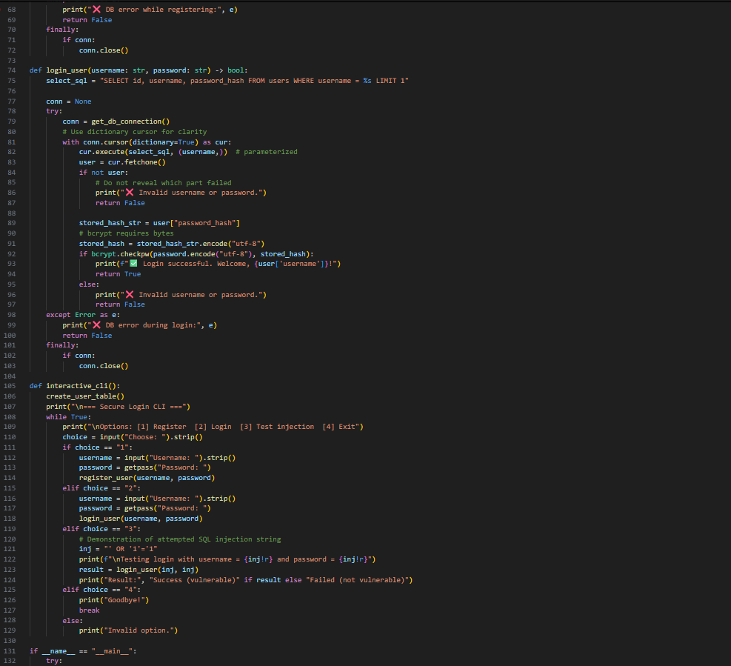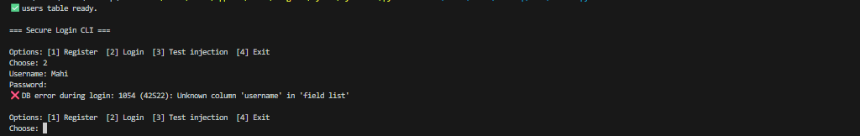

TASK-3:
Prompt:
Generate a Python script that reads and writes files based on user input.
Code and Output:
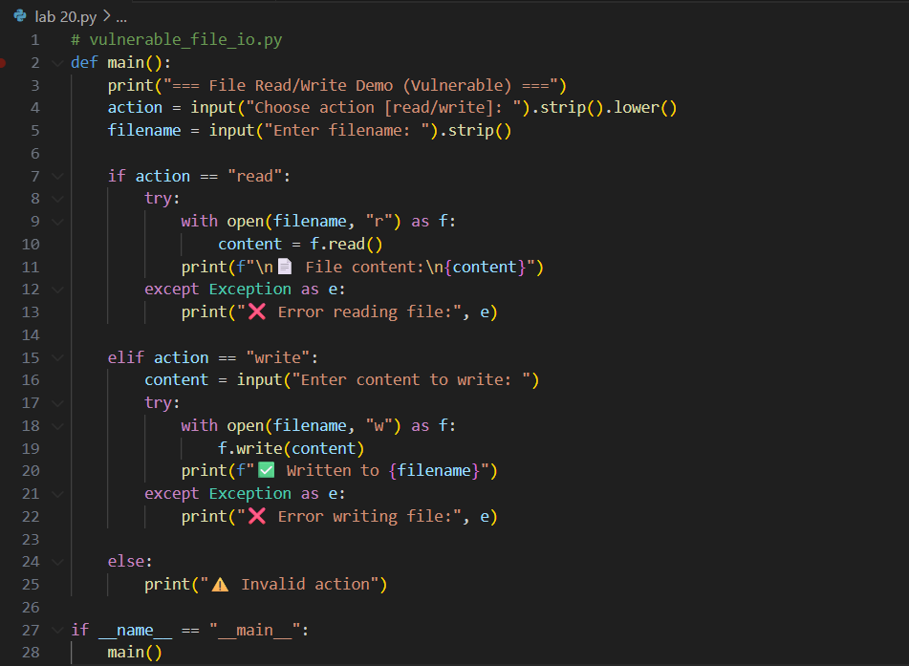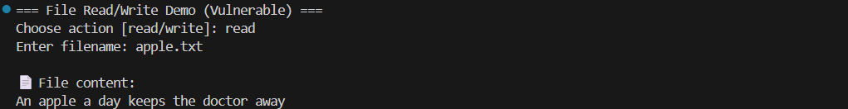
Vulnerability
- If a user inputs ../../etc/passwd as filename, the script will read/write files outside the intended directory.
- This is a path traversal attack.
Prompt:
Fix the vulnerability by validating file paths or restricting access to safe directories.
Code and Output:
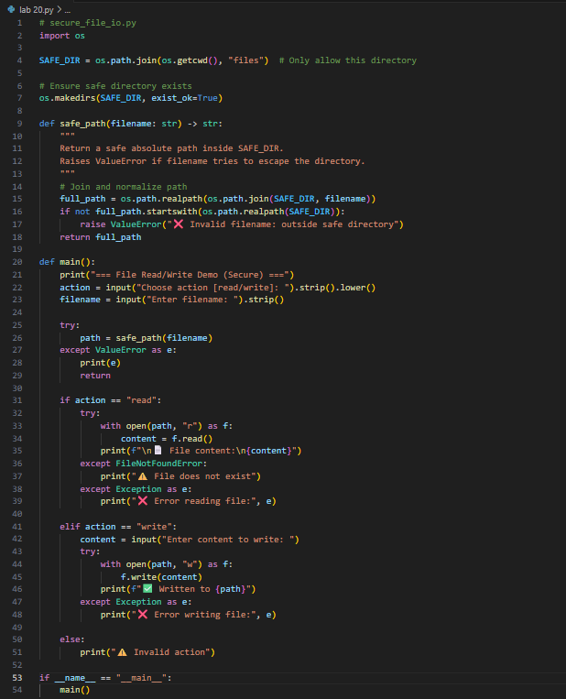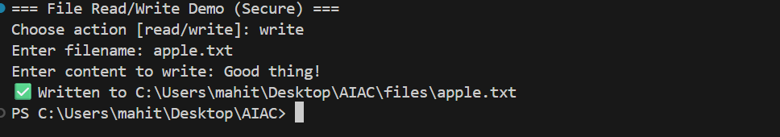
TASK-4:
Prompt:
Generate a calculator program that evaluates user input.
Code and Output:
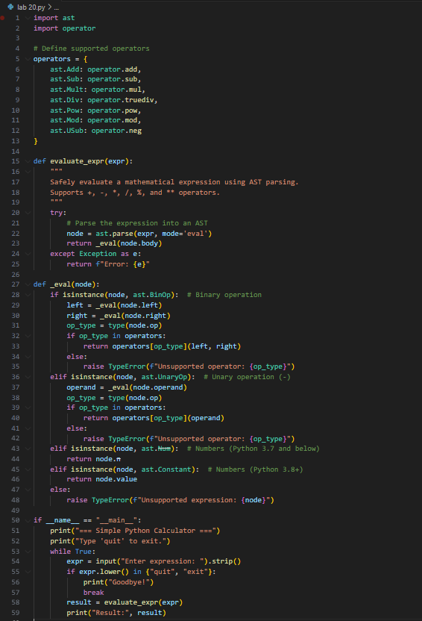
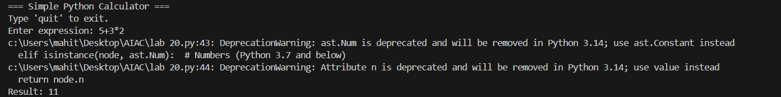
Prompt:
Replace it with a safe parser (e.g., ast.literal_eval() in Python)
Code and Output:
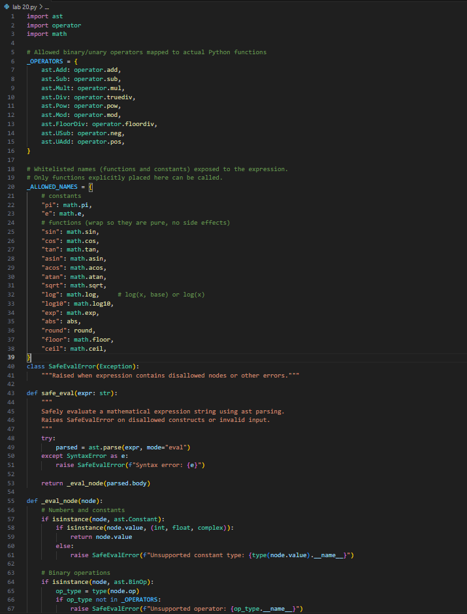
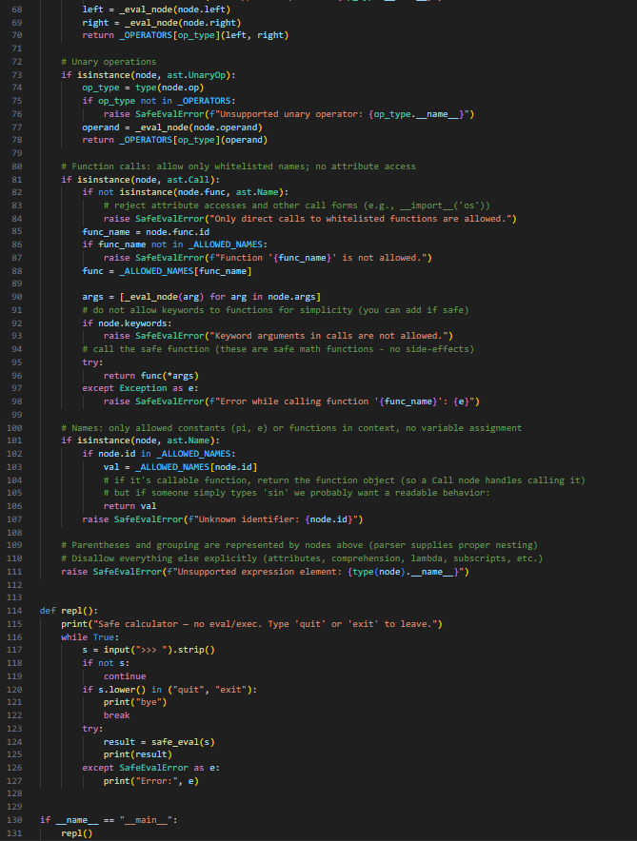

TASK-5:
Prompt:
Generate a web server script (Flask or Node.js)
Code and Output:
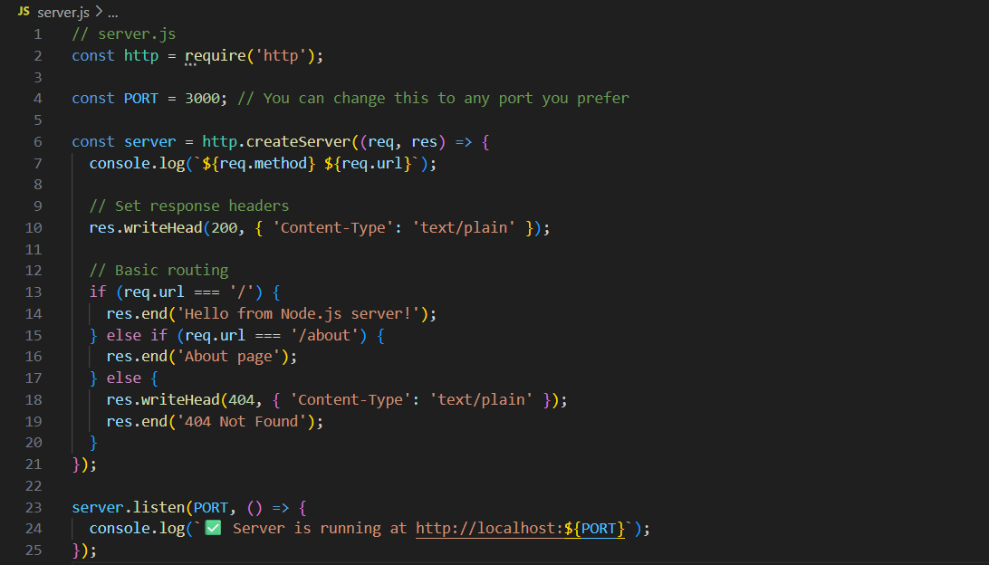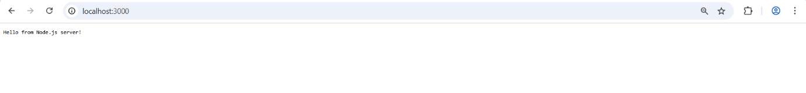

Prompt:
Fix the vulnerabilities and re-run the tool until no issues remain.
Code and Output:
